16th February 2022

Mazda2 Hybrid UK price and specification announced

- The Mazda2 Hybrid features a full self-charging hybrid powertrain and is available to order now.
- Result of collaboration between Mazda Motor Corporation and Toyota Motor Corporation.
- In the UK, the Mazda2 Hybrid will be sold alongside the well-established 2022 Mazda2.

Pricing and specification for the Mazda2 Hybrid has been announced. Arriving in the UK in May, and available to order now, the Mazda2 Hybrid will be offered across three trim grades: Pure, Agile and Select with prices from £20,300.
Bringing self-charging full hybrid powertrain technology to the Mazda model range for the first time, the Mazda2 Hybrid is a self-charging, full hybrid that combines a 1,490cc 92ps three-cylinder petrol engine with a 59kW electric motor for a total system power of 116ps The latest outcome of the long-standing collaboration between Mazda Motor Corporation and Toyota Motor Corporation, this Toyota Motor Europe OEM supplied model will be added to the Mazda2 European line-up as Mazda’s own brand vehicle.
In the UK, the Mazda2 Hybrid will be sold alongside the 2022 Mazda2, giving customers in the supermini segment the choice of two distinct models, depending on their needs. The seven-model 2022 Mazda2 range is priced from £16,575 to £20,945 all powered by the established 1.5-litre four-cylinder Skyactiv-G petrol engine.
Starting with the Pure grade, the Mazda2 Hybrid is priced from £20,300 with all models powered by the same 1.5-litre three-cylinder engine and hybrid drivetrain. The £21,150 Agile grade adds 15-inch alloy wheels, reversing camera,8-inch colour touch-screen centre display and smart keyless entry. There’s also the option to add the £980 Comfort Pack which brings styling additions like gloss black bumper mouldings and a gloss black front grille with lower satin chrome surround. It also sees the addition of LED headlights and front fog lights, plus inside, the Comfort Pack adds sports style front seats with black fabric with synthetic leather trim, plus dual-zone climate control.
At the top of the three-model range, the Mazda2 Hybrid Select features an extensive range of additional equipment which includes privacy glass, 16-inch alloys, power-fold mirrors, Qi Wireless smartphone charging and Blind Spot Monitoring with Parking Support Function to name just a few of the extra equipment items included in this grade. Across all model grades the Mazda2 Hybrid is offered with a choice of seven colours.

With a combined power output of 116ps driven via a CVT automatic transmission, Mazda’s new hybrid will accelerate from 0-62mph in 9.7 seconds and returns a WLTP combined cycle fuel economy of between 70.6 to 74.3mpg and CO₂ emissions of just 93-87g/km depending on the specification of 16” or 15” wheels.
At start-up the Mazda2 Hybrid automatically runs in EV mode, offering smooth, seamless and quiet running on electric motor power in urban environments, with zero CO₂, NOx and particulate emissions. During normal driving, power allocation is adjusted between the petrol engine and electric motor for optimum performance and the best possible fuel efficiency. During deceleration and under braking, kinetic energy is recovered as electrical energy for storage in the high-performance battery.
Battery power level is constantly managed via an engine-driven generator to remove any need to recharge the system from an external source. Although it is a compact B-segment vehicle, the new Mazda2 Hybrid’s long 2,560 mm wheelbase offers comfortable accommodation for up to four adults, as well as 286 litres of boot space.
The Mazda2 Hybrid is a highly significant car for Mazda in the context of the company’s commitment to fulfil the objectives laid out in ‘Sustainable Zoom-Zoom 2030’, its long-term vision for technological development. Specifically - in line with the Paris Agreement - its aim to reduce corporate average well-to-wheel CO₂ emissions by 50% by 2030 and, by accelerating the electrification of its fleet, achieve carbon neutrality by 2050.
Sold alongside the 2022 Mazda2, Mazda dealers in the UK will have the benefit of selling two distinct B-segment models, giving customers in the supermini sector the choice of two cars, depending on their needs.
2022 Mazda2
The 2022 Mazda2 is the latest update to Mazda’s popular supermini, the 2022 model-year sees the introduction of new trim levels and improved efficiency across the range. As before, the Mazda2 range is powered exclusively by the 1.5-litre Skyactiv-G petrol engine, and for the 2022 model year, the 115ps version has been reintroduced alongside the 75ps and 90ps outputs.

Starting with the £16,575 75ps SE-L, the seven-model 2022 Mazda2 range is topped with the new £20,945 115ps GT Sport Tech model. The 90ps engine is offered in SE-L and Sport trims, with Sport cars offered with manual and automatic transmission. The popular 90ps engine is also offered in GT Sport trim and the 2022 model year sees this trim also offered with a choice of transmission for the first time. The flagship 115ps GT Sport Tech is exclusively matched to the six-speed manual transmission, and with the exception of the entry-level 75ps SE-L, all manual versions of the 2022 Mazda2 feature Mazda’s M Hybrid mild-hybrid system and now wear the e-Skyactiv G badge.

Across all models the 1.5-litre petrol engine has been refined to offer considerable efficiency improvements. The compression ratio has increased from 13:1 to 15:1 with the exhaust upgraded from a 4-1 to a 4-2-1 manifold. As a result CO₂ emissions have dropped by 11 to 14g/km depending on output and transmission. As an example the popular 90ps Sport manual has dropped from 120g/km to 107g/km, while across the range the corresponding improvements in economy further enhance the Mazda2’s excellent cost of ownership credentials.

As has always been the case with the Mazda2, the 2022 Mazda2 sees excellent standard specifications across the entire range. All models in the range feature navigation, cruise control, integrated Bluetooth and climate controlled air conditioning, while the 2022 Mazda2 also sees the introduction of wireless Apple CarPlay from Sport trim onwards. From GT Sport trim onwards, the 2022 Mazda2 gets a colour head-up display, reversing camera, heated front seats and a heated steering wheel. The new range-topping 115ps GT Sport Tech has a standard equipment tally that includes items not normally found as standard in this sector, including Adaptive LED Headlights, Blind Spot Monitoring, Rear Smart City Brake Support and a 360 degree camera.

With a total of 12 colours to choose from across the range, the 2022 Mazda2 also sees the debut of Platinum Quartz Metallic, which complements the 2022 Mazda2’s unchanged Kodo design and sporty proportions.

Commenting on the arrival of the Mazda2 Hybrid, Jeremy Thomson, Managing Director Mazda UK said: “the Mazda2 Hybrid is the latest example of Mazda’s global collaboration with Toyota Motor Corporation and having available to our UK customers means we have the perfect car for customers looking for a small self-charging hybrid. It joins our battery electric Mazda MX-30 and the Mazda M Hybrid mild-hybrid equipped 2022 Mazda3, 2022 Mazda CX-30 and 2022 Mazda2* in our ever more efficient range”.

Adding, “it’s also great that the Mazda2 Hybrid will be sold alongside the 2022 Mazda2, as this ensures our customers will have the widest choice of small cars in UK showrooms. It may be the smallest car we produce, but it has at its heart the same values of style, driver involvement and quality that mark out all our vehicles. Thanks to being sold alongside the Mazda2 Hybrid, we have a pair of distinctive and premium contenders in what is still one of the most competitive segments in the UK car market.”

Ends

*2022 Mazda2 M Hybrid not on automatic models or 75ps SE-L

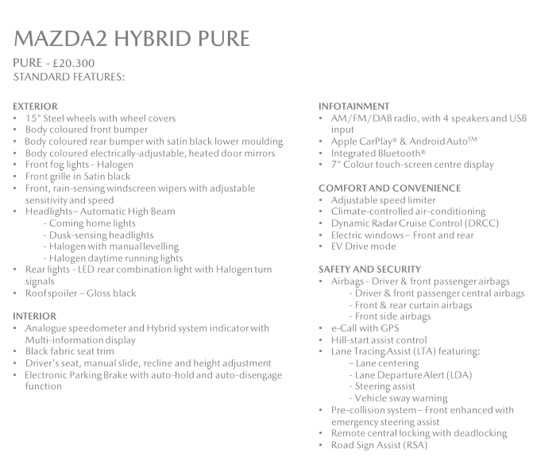

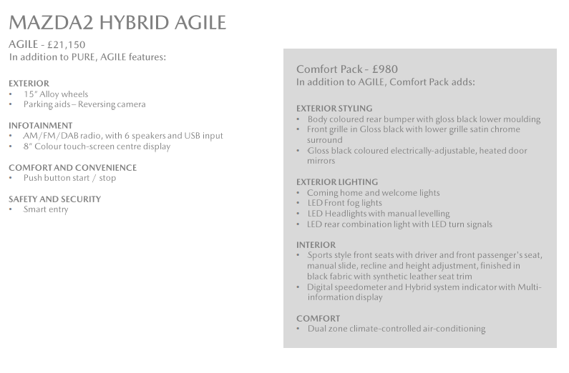

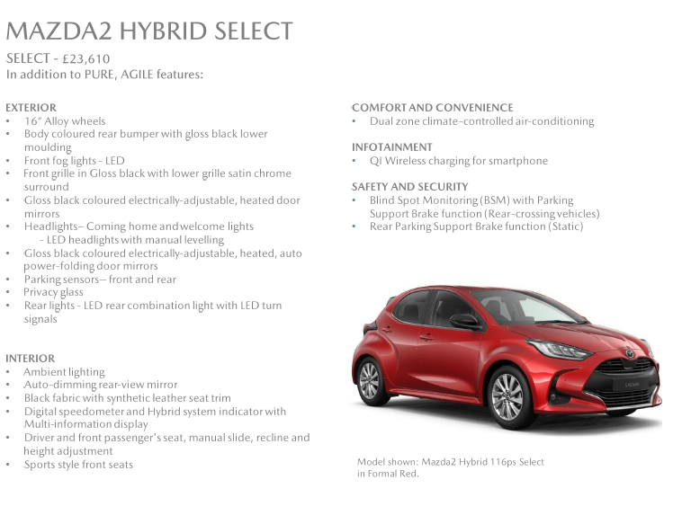

Further press information is available at www.mazda-press.co.uk
Interactive Press Packs for all models are available at www.mazdamediapacks.co.uk
Visit our media blog at www.insidemazda.co.uk
Follow us on Twitter @mazdaukpr

For further information please contact one of the following:
Graeme Fudge, PR Director | T: 01322 622 691 | E-mail: gfudge@mazdaeur.com
Owen Mildenhall, PR Manager | T: 01322 622 713 | Email: omildenhall@mazdaeur.com
Monique Clarke, Press Officer | T: 01322 622 650 | Email: mclarke@mazdaeur.com
Martine Varrall, Press Officer | T: 01322 622 776 | Email: mvarrall@mazdaeur.com

Ref: 220214draft

