Filling washer fluid
Washer fluid is used for cleaning the headlamps as well as the windscreen and rear window. Washer fluid with antifreeze must be used when the temperature is under the freezing point.
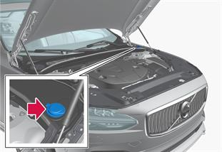
Filling of washer fluid takes place in the reservoir with a blue cap. The reservoir is used for windscreen washer, rear window washer and headlamp washers*

NOTE
When approx. 1 litre (1 qt) of washer fluid remains in the reservoir, the message Washer fluid Level low, refill is shown in the driver display, together with the symbol.
Prescribed grade: Washer fluid recommended by Volvo - with frost protection during cold weather and below freezing point.

IMPORTANT
Use Volvo genuine washer fluid or equivalent with a recommended pH of between 6 and 8, in working dilution (e.g. 1:1 with neutral water).

IMPORTANT
Use washer fluid with antifreeze when the temperature is below freezing to avoid freezing in the pump, reservoir and hoses.
Volume:
- Cars with headlamp washing: 5.5 litres (5.8 qts).
- Cars without headlamp washing: 3.5 litres (3.7 qts).

