Replacing windscreen wiper blades
The wiper blades sweep water away from the windscreen and rear window. Together with the washer fluid they clean the windows and ensure visibility for driving. Windscreen and rear window wiper blades can be replaced.

Replacing a windscreen wiper blade
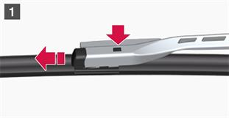
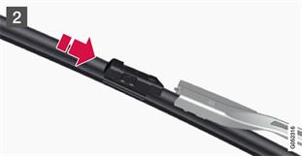
1
Fold up the wiper arm when it is in service position. Service position is activated/deactivated via the function view in the centre display when the car is stationary and the windscreen wipers are not on. Press the button located on the wiper blade mounting and pull straight out parallel with the wiper arm.
2
Slide in the new wiper blade until a "click" is heard.
3
Check that the blade is firmly installed.
4
Fold the wiper arm back towards the windscreen.
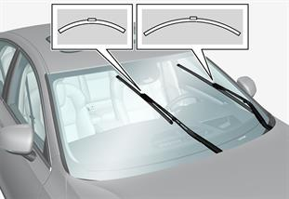
The wiper blades are different lengths.

NOTE
The wiper blades are different lengths. The blade on the driver's side is longer than on the passenger side.

